**Chapter 5**

**Substituent effects on the cyclic voltammetry reduction peak potentials of**

**4′-substituted (E)-1-(furan-2-yl)-3-phenylprop-2-ene-1-ones.**

**5.1 Introduction**

Cyclic voltammetry has become increasingly popular in all fields of chemistry as a means of studying redox states. In the cyclic voltammetry, the potential of the working electrode is scanned in one direction and the peaks are observed due to the reduction or oxidation of the substrate, by recording the cell current as a function of the applied potential. The potential can be scanned in the reverse direction and the peaks can be observed due to oxidation or reduction. The sweep rates used range from a few mV s-1 up to a few hundred V s-1. But high-quality data at fast scan rates can be obtained with a micro electrode (electrode diameter range = 0.5-50 µm). This permits the study of systems with much faster chemical reactions. This usefulness of cyclic voltammetry lies in the possibility of estimating the stability of intermediates formed in the electrode process and can provide information about the number of electrons transferred in each wave or peak. There are many articles that deal with the theory and practice of modern voltammetry in depth.1,2,3 Many authors have reported the substituent effects on peak potentials measured using cyclic voltammetry.4-7

Several authors8-17 have carried out numerous studies on various activated olefins. Bard and co-workers18 have extensively investigated the possible mechanistic path of the electro hydrodimerization reaction of diethyl fumarate using double potential-step chronoamperometry. Puglisi and Bard studied the electrochemical behaviour of different activated olefins at a rotating ring-disk electrode.19 Sulochana and Nagarajan have carried out the electrochemical reduction of 3-hydroxyflavone20 and 3-hydroxy-4′-methoxy-flavone.21 The electrochemical behaviour of α,β-unsaturated carbonyl compounds have also been reported by extensive polarographic studies in aqueous22-25 and non-aqueous10,26 -28 media.

Avaca and Utley29 have carried out extensive studies on cathodic hydrogenation of activated carbon-carbon double bonds of various unsaturated aromatic compounds. Many studies on the cathodic reductions of activated olefins have been concerned with hydrodimerization.30 Klemn *et al.*31,32 have carried out studies on the electroreduction of some α,β-unsaturated esters of cinnamic acid and substantiated Baizer’s observation that the electro hydrodimerization (EHD) reaction could be used to synthesize cyclic compounds.

Studies of substituent effects (LFER) on peak potential of cyclic voltammetry in various substituted fluoren-9-ones,7 4-substituted benzene-1,2-diols,5 5,13-disubstituted [2,2] meta-cyclophanes6 and substituted benzophenones7 have been reported in the literature.

(E)-1-(Furan-2-yl)-3-phenylprop-2-ene-1-one is an aromatic ketone that forms the central core for a variety of important biological compounds. Chemically they consist of open chain flavonoids in which the ends of a three carbon α, β-unsaturated carbonyl system is attached to a 2-furyl group and a substituted phenyl group. Some of the chalcone derivatives show antibacterial, antifungal, antitumor and anti-inflammatory properties.33 Chalcone derivatives possess conjugated double bonds and a completely delocalized π-electron system on both rings. Molecules possessing such system have relatively low redox potentials and have a greater probability of undergoing electron transfer reactions.34

Electrochemical methods have proved to be very sensitive for the determination of organic molecules, including drugs and related molecules in pharmaceutical dosage forms and biological fluids.35-39 A review of the literature reveals that many studies for the electrochemical behaviour of chalcone40,41 at a glassy carbon electrode are available. Hence 4′-substituted (E)-1-(furan-2-yl)-3-phenylprop-2-ene-1-one are chosen in the present investigation.

It was felt that the nature of reduction at glassy carbon electrode and the effect of substituents on the reduction could be investigated with this compound.

The applicability of the LFER to cyclic voltammetry is being examined in the present investigation. Therefore, measurements of the electrochemical parameters of 4′-substituted (E)-1-(furan-2-yl)-3-phenylprop-2-ene-1-one have been made by using cyclic voltammetry technique. The cyclic voltammetry technique is used to follow the reduction of these compounds since cyclic voltammetry technique possesses merits over polarography.42 The cyclic voltammetry technique has been used to characterize the reduction process.

The applicability of Hammett equation to the polarographic reduction potentials of a large variety of organic compounds, such as 4-styrylpyridines, azo dyes, styryl dyes etc. have been examined.43,44-49 Good LFER relationships were obtained with the E1/2 values and various substituent parameters. In this part, the effect of substituents in cathodic reactions of 4′-substituted (E)-1-(furan-2-yl)-3-phenylprop-2-ene-1-one is reported.

**5.2 Results and discussion**

Typical cyclic voltammograms at various sweep rates and at constant concentration

(10 mM) of (E)-1-(furan-2-yl)-3-phenylprop-2-ene-1-one in acetonitrile is shown in Figure (5.1). In all the above cases, two well-defined voltammetry peaks are observed in the potential region -1.309 to -1.348 V and -1.543 to -1.563 V. A small anodic peak is observed in the reverse scan for the first peak. This indicates the quasi-reversibility of the reaction under the experimental conditions employed. The first peak current (ip) is proportional to the square root of sweep rate (ν1/2) at a constant concentration (10 mm) (Fig.5.2) which is expected for a simple diffusion controlled process.50

In addition, there is a linear relationship between log ip and log ν, corresponding to the following equations (5.1) and (5.2) for the first peak and second peak respectively [Figures (5.3) and (5.4)].

log ip = 0.515 log ν + 2.850 (5.1)

r = 0.998

and

log ip = 0.474 log ν + 2.725 (5.2)

r = 0.993

The slopes of 0.515 and 0.474 are close to the theoretically expected value of 0.5 for a diffusion controlled process51.

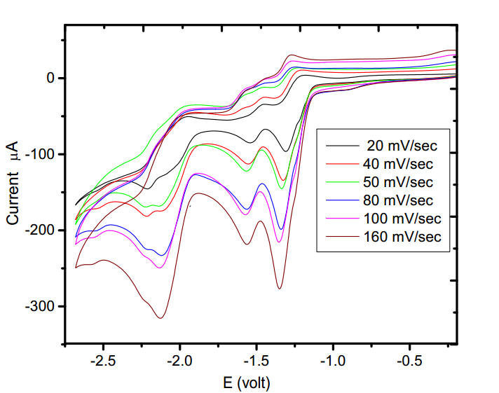 **Figure 5.1** Cyclic voltammograms of (E)-1-(furan-2-yl)-3-phenylprop-2-ene-1-one

(10 mM) in tetrabutylammonium tetrafluoroborate.

Solvent = acetonitrile;

Working electrode = glossy carbon;

Sweep rate = 20 mV/s, 40 mV/s, 50 mV/s, 80 mV/s, 100 mV/s and

160 mV/s.

.

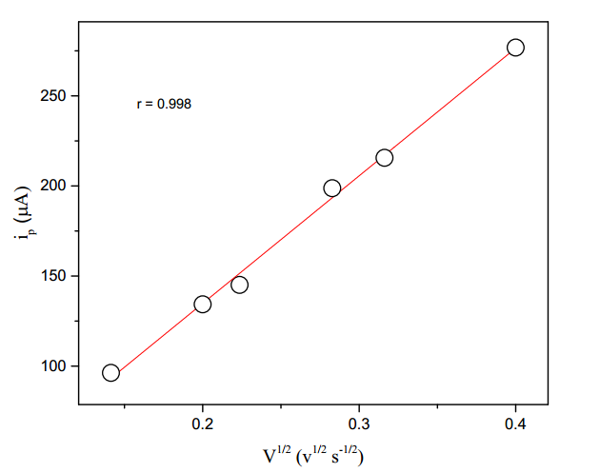

r = 0.998

s = 0.446

ν1/2 (ν1/2 s1/2)

**Figure 5.2** Plot of first peak current (ip) versus square root of sweep rates for the electrolytic

reduction of (E)-1-(furan-2-yl)-3-phenylprop-2-ene-1-one (10 mM) in tetrabutyl

ammonium tetrafluoroborate.

Solvent = acetonitrile.

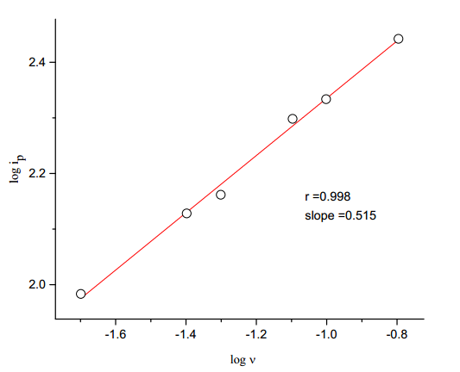

**Figure 5.3** Plot of logarithm of peak current on logarithm of scan rate for the first peak

for the electrolytic reduction of (E)-1-(furan-2-yl)-3-phenylprop-2-ene-1-one

(10 mM) in tetrabutylammonium tetrafluoroborate.

Solvent = acetonitrile.

.

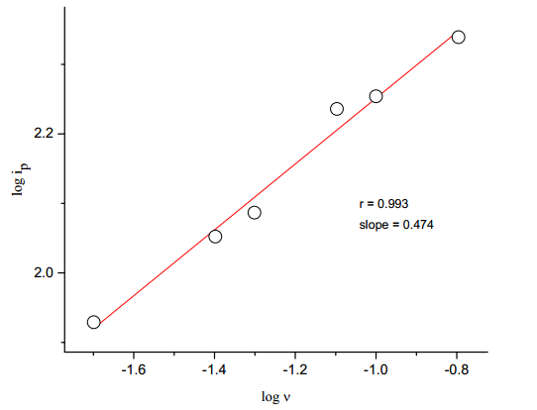

**Figure 5.4** Plot of logarithm of peak current on logarithm of sweep rate for the second peak

for the electrolytic reduction of (E)-1-(furan-2-yl)-3-phenylprop-2-ene-1-one

(10 mM) in tetrabutylammonium tetrafluoroborate.

Solvent = acetonitrile.

.

The cyclic voltammograms of (E)-1-(furan-2-yl)-3-phenylprop-2-ene-1-one in acetonitrile containing tetrabutylammonium tetrafluoro borate at various concentration and at constant sweep rate (40 mV s-1) are shown in Fig. (5.5). The first peak current is proportional to the concentration of (E)-1-(furan-2-yl)-3-phenylprop-2-ene-1-one at constant sweep rate (40 mV s-1) Fig. (5.6).

The peak potential shifts cathodically and the shifts are very small with an increase in sweep rate and concentration, and there is a small anodic peak for the first peak which is characteristic of quasi-reversible charge transfer reaction. A linear dependence of Ep of the first peak vs log ν (Fig.5.7) (correlation coefficient, r = 0.927) also confirms that the system corresponds to the quasi-reversible cyclic voltammetric pattern. The peak current function ip/ACν1/2 where A is the area of the electrode, C is the substrate concentration and ν is the sweep rate, remains almost constant (Table 5.1). The above facts suggest that the electrochemical reduction is quasi-reversible and involves diffusion controlled electron transfer. Similar observations are also observed for the second peak (see Figs. 5.8 & 5.9).

The differences between peak potentials and half-peak potentials (Ep - Ep1/2 ) are also nearly constant. The transfer coefficient (αna) calculated by using equation (5.3) is found to be a fraction (Table 5.1). As an example, the αna value is found to be 0.43 for the parent compound at 40 mV s-1 sweep rate and 10 mM concentration.

[Grab your reader’s attention with a great quote from the document or use this space to emphasize a key point. To place this text box anywhere on the page, just drag it.]

Ep - Ep1/2 = (5.3)

The diffusion coefficient (D) of (E)-1-(furan-2-yl)-3-phenylprop-2-ene-1-one is taken as 3.11487 x 10-4 Cm2 s-1 for the related compound from the literature.40 Using these values and according to the quasi-reversible electrode process, Ip is defined by the equation52 (5.4)

Ip = 2.69 × 105 × n (αna)1/2 × A × D1/2 × ν1/2 × C (5.4)

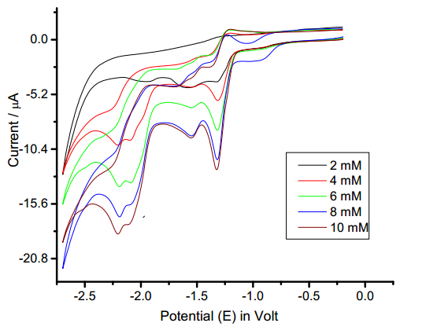

**Figure 5.5** Cyclic voltammograms of (E)-1-(furan-2-yl)-3-phenylprop-2-ene-1-one

in tetrabutylammonium tetrafluoroborate.

Solvent = acetonitrile;

Sweep rate = 40 mV/s ;

working electrode = glassy carbon

[substrate] =2 mM; 4 mM; 6 mM; 8 mM and 10 mM

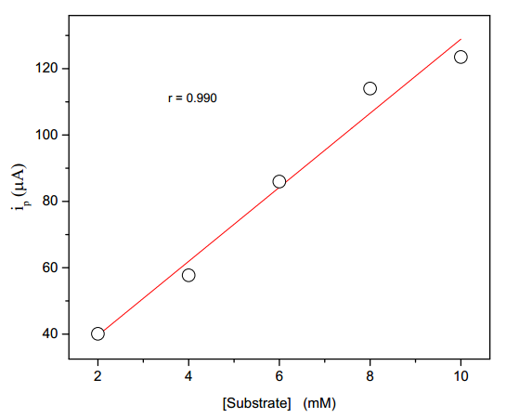

r = 0.990

s = 5.922

**Figure 5.6** Plot of first peak current (ip) versus concentration of (E)-1-(furan-2-yl)-3-

phenylprop-2-ene-1-one in tetrabutylammonium tetrafluoroborate.

Solvent = acetonitrile;

Sweep rate = 40 mV/s

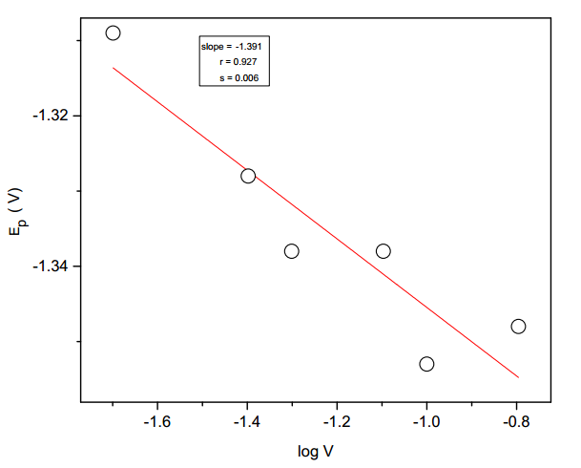

r = 0.927

S = 0.006

log ν

**Figure 5.7** Plot of Ep of first peak versus log ν for the electrolytic reduction of (E)-1-

(furan-2-yl)-3-phenylprop-2-ene-1-one in tetrabutylammonium tetrafluoroborate.

Solvent = acetonitrile.

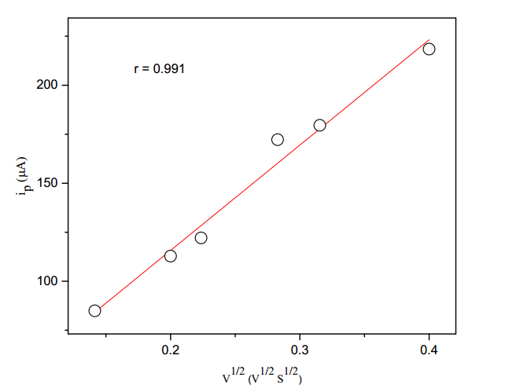 **Figure 5.8**  Plot of second peak current (ip) versus square root of sweep rate for the

r = 0.991

s = 0.736

ν1/2 (ν1/2s1/2)

electrolytic reduction of (E)-1-(furan-2-yl)-3-phenylprop-2-ene-1-one in tetrabutyl

ammonium tetrafluoroborate.

Solvent = acetonitrile.

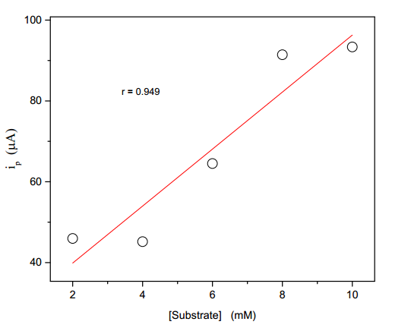

r = 0.949

s = 0.859

**Figure 5.9** Plot of second peak (ip) versus concentration of (E)-1-(furan-2-yl)-3-

phenylprop-2-ene-1-one in tetrabutylammonium tetrafluoroborate.

Solvent = acetonitrile;

Sweep rate = 40 mV/s.

|  |  |  |  |  |  |  |  |  |  |  |  |  |  |  |  |  |  |  |  |  |  |
| --- | --- | --- | --- | --- | --- | --- | --- | --- | --- | --- | --- | --- | --- | --- | --- | --- | --- | --- | --- | --- | --- |
| **Table 5.1**: Cyclic voltammetric data of (E)-1-(furan-2-yl)-3-phenylprop-2-ene-1-one reduction on glassy carbon  electrode in acetonitrile at sweep rate 40 mV s-1. | | | | | | | | | | | | | | | | | | | | | |
|  |  | |  | | |  | | |  | |  | |  |  | |  | | |  | | | |  |  |  |
|  | | First peak | | | | | | | |  | | Second peak | | | | | | | | |
| [Substrate] | | ip | | ip/ACν1/2 | -Ep | | - Ep1/2 | αna | |  | | ip | | | ip/ACν1/2 | | -Ep | - Ep1/2 | | αna |
| (mM) | | (µA) | |  | (V) | | (V) |  | |  | | (µA) | | |  | | (V) | (V) | |  |
|  | |  | |  |  | |  |  | |  | |  | | |  | |  |  | |  |
| 2 | | 40.07 | | 3190 | 1.318 | | 1.216 | 0.47 | |  | | 45.97 | | | 3660 | | 1.530 | 1.235 | | 0.16 |
| 4 | | 57.71 | | 2297 | 1.315 | | 1.232 | 0.58 | |  | | 45.17 | | | 1798 | | 1.529 | 1.232 | | 0.16 |
| 6 | | 85.97 | | 2281 | 1.320 | | 1.232 | 0.55 | |  | | 64.51 | | | 1712 | | 1.550 | 1.114 | | 0.11 |
| 8 | | 114.00 | | 2269 | 1.325 | | 1.249 | 0.63 | |  | | 91.43 | | | 1819 | | 1.550 | 1.349 | | 0.24 |
| 10 | | 123.50 | | 1967 | 1.328 | | 1.241 | 0.55 | |  | | 93.35 | | | 1491 | | 1.554 | 1.290 | | 0.18 |
|  | |  | |  |  | |  |  | |  | |  | | |  | |  |  | |  |

where α is the transfer coefficient, na the number of electrons transferred, ν the scan rate, A is the electrode area, D is the diffusion coefficient and C is the concentration of electroactive spices. Thus, for the first peak the value of αna is calculated from equation (5.3) as 0.466 V, ip from graph as 198.7 µA, area of the electrode A is 0.0314 cm2, the scan rate ν is 80 mV and the concentration C is 10 mM for which the number electrons transferred ‘n’ for the first stage of reduction using equation (5.4) was calculated to be 0.979 ≈ 1.

Similarly, for the second peak the value of αna is calculated from equation (5.3) as 0.253 V, ip from graph as 172.2 µA, area of the electrode A is 0.0314 cm2, the scan rate ν is 80 mV and the concentration C is 10 mM for which the number electrons transferred ‘n’ for the second stage of reduction using equation (5.4) was calculated to be 0.81 ≈ 1. Thus, an overall number of electrons transferred is calculated to be 2.

The present investigation reveals that (E)-1-(furan-2-yl)-3-phenylprop-2-ene-1-one and 4′-substituted (E)-1-(furan-2-yl)-3-phenylprop-2-ene-1-ones in acetonitrile take place in two successive stages at well-separated cathode potentials to give two-electron reduction process. From the observed facts and already available literature for similar compounds such as styrylpyridine53 and 4-(chlorostyryl) pyridine45  where the carbon-carbon double bond was reduced electrochemically, the electrochemical reduction mechanism of (E)-1-(furan-2-yl)-3-phenylprop-2-ene-1-one shown in scheme (5.1) may be proposed.

The course of reduction of (E)-1-(furan-2-yl)-3-phenylprop-2-ene-1-one (a) is probably the addition of one electron to the lowest-energy antibonding molecular orbital to give the anion radical (b) which may undergo protonation at the most basic centre, the oxygen atom. This gives a radical of which, (c) is one canonical form. The radical appears to be reduced further to a carbanion which may be protonated to give (d).



**Scheme 5.1**

**5.3 Substituent effect**

In order to understand the nature of the species formed during the course of the reaction and to test the applicability of LFER, the cyclic voltammograms for various 4′- substituted (E)-1-(furan-2-yl)-3-phenylprop-2-ene-1-ones were also measured at constant [substrate] and at varying sweep rates were measured. The cyclic voltammograms of 4′- substituted (E)-1-(furan-2-yl)-3-phenylprop-2-ene-1-ones are shown in Figs. (5.10),(5.11) and (5.12). By employing similar procedure adopted for parent compound the calculation of αna was made for all the substituent compounds. The αna values are found to have fractional values. The voltammetry responses of 4′- substituted (E)-1-(furan-2-yl)-3-phenylprop-2-ene-1-ones are collected in Table (5.2). Analysis of these values of peak potentials reveals that the peak potentials increases cathodically with an increase in sweep rate for all the 4′- substituted (E)-1-(furan-2-yl)-3-phenylprop-2-ene-1-ones. The cyclic voltammograms on glassy carbon working electrode for the 4′-substituted (E)-1-(furan-2-yl)-3-phenylprop-2-ene-1-ones markedly depended on the electronic nature of the substituent in the compounds. The peak-to-peak potential separation is large from -NMe2 to -CHO, generally in the range of several hundred millivolts.

The parameters αna and current function, irreversible and diffusion controlled nature of reduction lie practically in the same range for all the members of the series. Therefore, it is possible to apply the Hammett relation to the series.54 For this purpose, the peak potentials and half-peak potentials for (E)-1-(furan-2-yl)-3-phenylprop-2-ene-1-one derivatives with substituents in the phenyl ring were considered for the correlation.

**Correlation analysis with Ep values for the first peak**

Ep = 0.350 *σ*p  - 1.285 (5.5)

r = 0.993; s = 0.019; ψ = 0.145

[substrate] = 10 mM; sweep rate = 20 mV s-1

Ep = 0.353 *σ*p  - 1.294 (5.6)

r = 0.991; s = 0.022; ψ = 0.164

[substrate] = 10 mM; sweep rate = 40 mV s-1

Ep = 0.349 *σ*p  - 1.311 (5.7)

r = 0.974; s = 0.039; ψ = 0.277

[substrate] = 10 mM; sweep rate = 80 mV s-1

Ep = 0.348 *σ*p  - 1.325 (5.8)

r = 0.992; s = 0.022; ψ = 0.155

[substrate] = 10 mM; sweep rate = 160 mV s-1

Ep = 0.342 *σ*p  - 1.342 (5.9)

r = 0.989; s = 0.027; ψ = 0.191

[substrate] = 10 mM; sweep rate = 320 mV s-1

**Correlation analysis with Ep1/2 values for the first peak**

Ep1/2 = 0.385 *σ*p  - 1.199 (5.10)

r = 0.999; s = 0.008; ψ = 0.055

[substrate] = 10 mM; sweep rate = 20 mV s-1

Ep1/2 = 0.377 *σ*p  - 1.206 (5.11)

r = 0.998; s = 0.012; ψ = 0.077

[substrate] = 10 mM; sweep rate = 40 mV s-1

Ep1/2 = 0.371 *σ*p  - 1.204 (5.12)

r = 0.995; s = 0.017; ψ = 0.122

[substrate] = 10 mM; sweep rate = 80 mV s-1

Ep1/2 = 0.362 *σ*p  - 1.218 (5.13)

r = 0.996; s = 0.014; ψ = 0.109

[substrate] = 10 mM; sweep rate = 160 mV s-1

Ep1/2 = 0.339 *σ*p  - 1.221 (5.14)

r = 0.989; s = 0.027; ψ = 0.191

[substrate] = 10 mM; sweep rate = 160 mV s-1

**Correlation analysis with Ep values for the second peak**

Ep = 0.311 *σ*p / *σ*p-  - 1.731 (5.15)

r = 0.857; s = 0.126; ψ = 0.631

[substrate] = 10 mM; sweep rate = 20 mV s-1

Ep = 0.307 *σ*p / *σ*p-  - 1.736 (5.16)

r = 0.855; s = 0.126; ψ = 0.635

[substrate] = 10 mM; sweep rate = 40 mV s-1

Ep = 0.297 *σ*p / *σ*p-  - 1.749 (5.17)

r = 0.839; s = 0.130; ψ = 0.666

[substrate] = 10 mM; sweep rate = 80 mV s-1

Ep = 0.293 *σ*p / *σ*p-  - 1.756 (5.18)

r = 0.826; s = 0.135; ψ = 0.690

[substrate] = 10 mM; sweep rate = 160 mV s-1

Ep = 0.301 *σ*p / *σ*p-  - 1.870 (5.19)

r = 0.920; s = 0.099; ψ = 0.506

[substrate] = 10 mM; sweep rate = 320 mV s-1

**Correlation analysis with Ep1/2 values for the second peak**

Ep1/2 = 0.298 *σ*p / *σ*p-  - 1.580 (5.20)

r = 0.833; s = 0.134; ψ = 0.678

[substrate] = 10 mM; sweep rate = 20 mV s-1

Ep1/2 = 0.285 *σ*p / *σ*p-  - 1.580 (5.21)

r = 0.813; s = 0.138; ψ = 0.713

[substrate] = 10 mM; sweep rate = 40 mV s-1

Ep1/2 = 0.285 *σ*p / *σ*p-  - 1.578 (5.22)

r = 0.839; s = 0.130; ψ = 0.666

[substrate] = 10 mM; sweep rate = 80 mV s-1

Ep1/2 = 0.288 *σ*p / *σ*p-  - 1.560 (5.23)

r = 0.826; s = 0.135; ψ = 0.690

[substrate] = 10 mM; sweep rate = 160 mV s-1

Ep1/2 = 0.286 *σ*p / *σ*p-  - 1.620 (5.24)

r = 0.838; s = 0.099; ψ = 0.506

[substrate] = 10 mM; sweep rate = 320 mV s-1

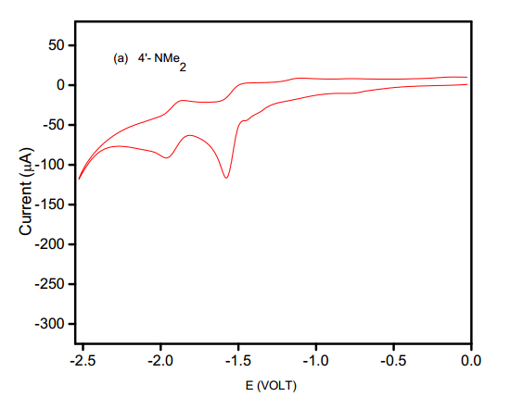

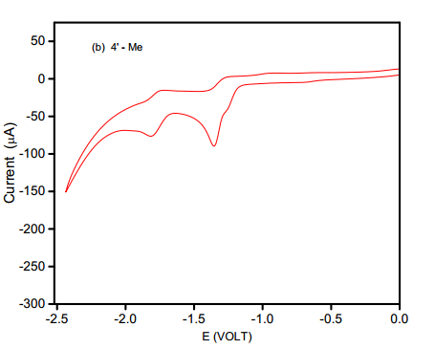

**Figure 5.10**. Cyclic voltammograms for

**(a)** (E)-1-(Furan-2-yl)-3-(4′-N, N-dimethylaminophenyl)-prop-2-ene-1-one and

**(b)** (E)-1-(Furan-2-yl)-3-(4′-methylaminophenyl)-prop-2-ene-1- one

in tetrabutylammonium tetrafluoroborate.

Solvent = acetonitrile; working electrode = glassy carbon; Sweep rate = 40 mV/s

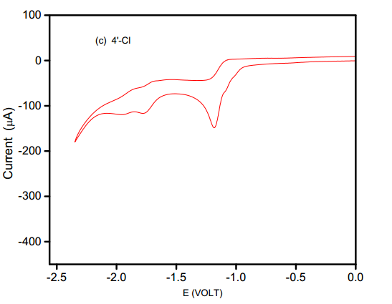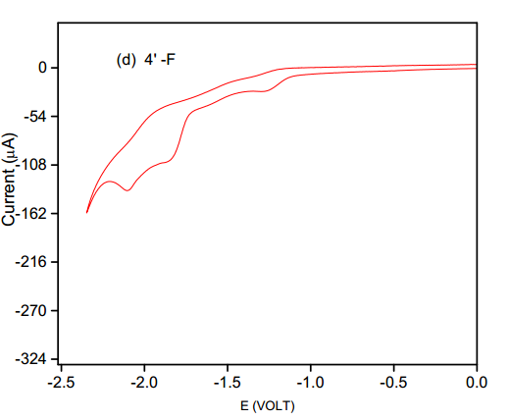

(a)

(b)

(a)

**Figure 5.11**. Cyclic voltammograms for

**(a)** (E)-1-(Furan-2-yl)-3-(4′-chlorophenyl)-prop-2-ene-1-one and

**(b)** (E)-1-(Furan-2-yl)-3-(4′-flurophenyl)-prop-2-ene-1-one

in tetra butylammonium tetrafluoroborate.

Solvent = acetonitrile; working electrode = glassy carbon; Sweep rate = 40 mV/s

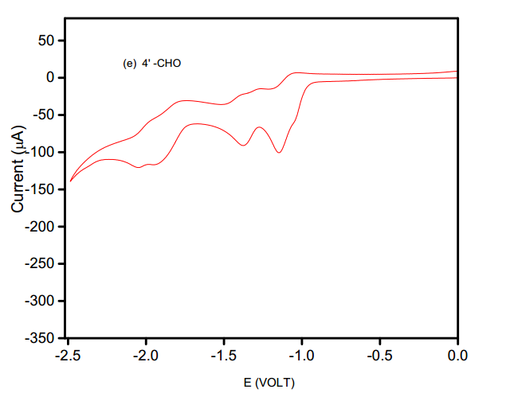

**Figure 5.12**. Cyclic voltammogram for (E)-1-(furan-2-yl)-3-(4′-oxophenyl)-prop-2-ene-1-one in

tetrabutylammonium tetrafluoroborate.

Solvent = acetonitrile;

working electrode = glassy carbon;

Sweep rate = 40 mV/s

|  |  |  |  |  |  |  |  |  |  |  |  |  |  |  |
| --- | --- | --- | --- | --- | --- | --- | --- | --- | --- | --- | --- | --- | --- | --- |
|  | | **Table 5.2** : Cyclic voltammetric data of 4′-substituted (E)-1-(furan-2-yl)-3-phenylprop-2-ene-1-ones reduction  on glassy carbon electrode in acetonitrile  [substrate] = 10 mM | | | | | | | | | | | | |
|  | | | |  |  |  |  |  |  |  |  |  |  |  |
|  | | | | First peak  --------------------------------------------------------- | | | | |  | Second peak  -------------------------------------------------------------- | | | | |
|  |
| S.No. | Substituent | | Sweep | ip | ip/ACν1/2 | -Ep | - Ep1/2 | αna |  | ip | ip/ACν1/2 | -Ep | - Ep1/2 | αna |
|  |  | | rate |  |  |  |  |  |  |  |  |  |  |  |
|  |  | | (mV s-1) | (µA) |  | (V) | (V) |  |  | (µA) |  | (V) | (V) |  |
|  |  | |  |  |  |  |  |  |  |  |  |  |  |  |
| 1 | NMe2 | | 20 | 81.67 | 1839 | 1.567 | 1.512 | 0.87 |  | 65.86 | 1483 | 1.964 | 1.809 | 0.31 |
|  |  | | 40 | 116.60 | 1857 | 1.577 | 1.510 | 0.72 |  | 91.43 | 1456 | 1.966 | 1.788 | 0.27 |
|  |  | | 80 | 158.20 | 1781 | 1.590 | 1.508 | 0.59 |  | 125.30 | 1411 | 1.966 | 1.789 | 0.27 |
|  |  | | 160 | 215.90 | 1719 | 1.608 | 1.510 | 0.49 |  | 178.60 | 1422 | 1.974 | 1.784 | 0.25 |
|  |  | | 320 | 295.50 | 1664 | 1.621 | 1.492 | 0.37 |  | 262.40 | 1477 | 1.984 | 1.765 | 0.22 |
|  |  | |  |  |  |  |  |  |  |  |  |  |  |  |
| 2 | Me | | 20 | 66.16 | 1490 | 1.350 | 1.274 | 0.63 |  | 65.95 | 1485 | 1.824 | 1.667 | 0.31 |
|  |  | | 40 | 87.60 | 1395 | 1.355 | 1.277 | 0.62 |  | 76.42 | 1217 | 1.819 | 1.657 | 0.30 |
|  |  | | 80 | 139.80 | 1579 | 1.365 | 1.261 | 0.46 |  | 111.10 | 1251 | 1.819 | 1.650 | 0.28 |
|  |  | | 160 | 201.20 | 1602 | 1.378 | 1.281 | 0.49 |  | 177.60 | 1414 | 1.827 | 1.626 | 0.24 |
|  |  | | 320 | 267.90 | 1508 | 1.396 | 1.282 | 0.42 |  | 238.30 | 1342 | 1.840 | 1.639 | 0.23 |
|  |  | |  |  |  |  |  |  |  |  |  |  |  |  |
| 3 | H | | 20 | 96.25 | 2167 | 1.309 | 1.206 | 0.47 |  | 84.93 | 1913 | 1.543 | 1.384 | 0.30 |
|  |  | | 40 | 134.30 | 2139 | 1.328 | 1.216 | 0.43 |  | 112.80 | 1796 | 1.553 | 1.384 | 0.28 |
|  |  | | 50 | 145.10 | 2067 | 1.338 | 1.226 | 0.43 |  | 122.10 | 1739 | 1.568 | 1.389 | 0.27 |
|  |  | | 80 | 198.70 | 2237 | 1.338 | 1.231 | 0.45 |  | 172.20 | 1939 | 1.568 | 1.378 | 0.25 |
|  |  | | 100 | 215.60 | 2171 | 1.353 | 1.233 | 0.40 |  | 174.50 | 1757 | 1.573 | 1.390 | 0.26 |
|  |  | | 160 | 276.80 | 2204 | 1.348 | 1.236 | 0.43 |  | 218.40 | 1739 | 1.563 | 1.329 | 0.21 |
|  |  | |  |  |  |  |  |  |  |  |  |  |  |  |
| 4 | F | | 20 | 19.71 | 444 | 1.270 | 1.169 | 0.48 |  | 87.18 | 1963 | 1.838 | 1.729 | 0.44 |
|  |  | | 40 | 27.20 | 433 | 1.270 | 1.191 | 0.61 |  | 104.80 | 1669 | 1.848 | 1.730 | 0.41 |
|  |  | | 80 | 38.83 | 437 | 1.277 | 1.168 | 0.44 |  | 128.27 | 1444 | 1.875 | 1.736 | 0.35 |
|  |  | | 160 | 42.77 | 341 | 1.321 | 1.206 | 0.42 |  | 179.33 | 1428 | 1.884 | 1.766 | 0.41 |
|  |  | | 320 | 64.14 | 361 | 1.357 | 1.237 | 0.40 |  | 232.66 | 1310 | 1.90 | 1.807 | 0.52 |
|  |  | |  |  |  |  |  |  |  |  |  |  |  |  |
| 5 | Cl | | 20 | 99.18 | 2233 | 1.176 | 1.112 | 0.75 |  | 88.60 | 1995 | 1.748 | 1.552 | 0.24 |
|  |  | | 40 | 148.50 | 2365 | 1.184 | 1.114 | 0.69 |  | 117.50 | 1871 | 1.756 | 1.585 | 0.28 |
|  |  | | 80 | 201.60 | 2270 | 1.197 | 1.116 | 0.60 |  | 149.60 | 1684 | 1.776 | 1.581 | 0.25 |
|  |  | | 160 | 290.6 | 2314 | 1.215 | 1.128 | 0.55 |  | 178.80 | 1796 | 1.788 | 1.534 | 0.19 |
|  |  | | 320 | 392.3 | 2209 | 1.236 | 1.13 | 0.45 |  | 305.80 | 1722 | 1.802 | 1.578 | 0.21 |
|  |  | |  |  |  |  |  |  |  |  |  |  |  |  |
| 6 | CHO | | 20 | 70.01 | 1577 | 1.137 | 1.028 | 0.44 |  | 66.44 | 1496 | 1.368 | 1.243 | 0.38 |
|  |  | | 40 | 100.70 | 1604 | 1.147 | 1.034 | 0.42 |  | 91.03 | 1450 | 1.375 | 1.240 | 0.36 |
|  |  | | 80 | 145.70 | 1641 | 1.160 | 1.040 | 0.40 |  | 129.30 | 1456 | 1.391 | 1.239 | 0.32 |
|  |  | | 160 | 210.30 | 1674 | 1.178 | 1.051 | 0.38 |  | 187.40 | 1492 | 1.404 | 1.230 | 0.28 |
|  |  | | 320 | 296.30 | 1668 | 1.196 | 1.060 | 0.35 |  | 267.60 | 1507 | 1.412 | 1.226 | 0.26 |

The results of statistical analysis are described in Table (5.3) and the results are given by Eqs. (5.5 – 5.24). The corresponding Hammett plots Ep vs σp at 40 mV s-1, Ep1/2 vs σp at 40 mV s-1 for the first peak and Ep vs σp /σp- at 320 mV s-1, Ep1/2 vs σp/σp- at 320 mV s-1 for the second peak are illustrated in Figs.(5.13),(5.14),(5.15) and (5.16). The Hammett correlation of Ep vs σp at 40 mV s-1 for the first peak shows an excellent correlation (r=0.993). The Hammett correlation for the second peak is poor. This result is in agreement with the results for 4-(4-halostyryl) pyridines.45 This is because, as is depicted in the scheme (5.2),



**Scheme 5.2**

the addition of the first electron to the halogen substituted compounds (a), produces a radical anion (b) which in some cases may initiate a series of reaction to produce (E)-1-(furan-2-yl)-3-phenylprop-2-ene-1-one radical (c). The radical being reduced in the second peak is then unrelated to the original substrate. Very low value of *ρ* (Table 5.3) observed for the second peak also supports this mechanism.45

The positive value of the reaction constant (*ρ*) is in accordance with the mechanism involving an update of an electron by the substrate.55

|  |  |  |  |  |  |  |  |  |  |  |  |  |  |
| --- | --- | --- | --- | --- | --- | --- | --- | --- | --- | --- | --- | --- | --- |
| **Table 5.3** : Hammett correlations for the voltammetry reduction of 4′-substituted (E)-1-(furan-2-yl)-3-phenylprop-2- ene-1-ones on glassy  carbon electrode in acetonitrile | | | | | | | | | | | | | |
|
| [substrate] = 10 mM supporting electrolyte = tetrabutylammonium tetrafluoroborate | | | | | | | | | | | | | |
|  | | first peak | | | | | |  |  | Second peak | | | |
|  |
| Quantity | Substituent | Sweep | correlation | slope | standard | n | ψ |  | correlation | slope | standard | n | ψ |
| correlated | constant | rate | coefficient |  | deviation |  |  |  | coefficient |  | deviation |  |  |
|  |  | (mV/s) |  |  |  |  |  |  |  |  |  |  |  |
|  |  |  |  |  |  |  |  |  |  |  |  |  |  |
| Ep(V) | σp | 20 | 0.993 | 0.350±0.020 | 0.019 | 6 | 0.145 |  | 0.747 | 0.378±0.168 | 0.163 | 6 | 0.814 |
|  |  | 40 | 0.991 | 0.353±0.023 | 0.022 | 6 | 0.164 |  | 0.743 | 0.371±0.167 | 0.162 | 6 | 0.820 |
|  |  | 80 | 0.974 | 0.349±0.040 | 0.039 | 6 | 0.277 |  | 0.718 | 0.353±0.171 | 0.166 | 6 | 0.852 |
|  |  | 160 | 0.992 | 0.348±0.022 | 0.022 | 6 | 0.155 |  | 0.709 | 0.350±0.174 | 0.169 | 6 | 0.864 |
|  |  | 320 | 0.989 | 0.342±0.028 | 0.027 | 5 | 0.191 |  | 0.745 | 0.340±0.176 | 0.170 | 5 | 0.861 |
|  |  |  |  |  |  |  |  |  |  |  |  |  |  |
|  | σp / σp- | 20 | 0.931 | 0.236±0.046 | 0.062 | 6 | 0.447 |  | 0.857 | 0.311±0.094 | 0.126 | 6 | 0.631 |
|  |  | 40 | 0.927 | 0.237±0.048 | 0.064 | 6 | 0.459 |  | 0.855 | 0.307±0.093 | 0.126 | 6 | 0.635 |
|  |  | 80 | 0.919 | 0.237±0.050 | 0.068 | 6 | 0.483 |  | 0.839 | 0.297±0.096 | 0.130 | 6 | 0.666 |
|  |  | 160 | 0.930 | 0.234±0.046 | 0.062 | 6 | 0.450 |  | 0.826 | 0.293±0.100 | 0.135 | 6 | 0.690 |
|  |  | 320 | 0.935 | 0.232±0.051 | 0.068 | 5 | 0.458 |  | 0.920 | 0.302±0.074 | 0.099 | 5 | 0.506 |
|  |  |  |  |  |  |  |  |  |  |  |  |  |  |
|  | σp+/ σp- | 20 | 0.958 | 0.165±0.024 | 0.049 | 6 | 0.351 |  | 0.845 | 0.209±0.066 | 0.131 | 6 | 0.655 |
|  |  | 40 | 0.953 | 0.166±0.026 | 0.052 | 6 | 0.371 |  | 0.844 | 0.207±0.065 | 0.129 | 6 | 0.657 |
|  |  | 80 | 0.932 | 0.163±0.032 | 0.063 | 6 | 0.444 |  | 0.826 | 0.199±0.067 | 0.134 | 6 | 0.690 |
|  |  | 160 | 0.959 | 0.165±0.024 | 0.047 | 6 | 0.347 |  | 0.818 | 0.198±0.069 | 0.137 | 6 | 0.704 |
|  |  | 320 | 0.965 | 0.163±0.023 | 0.050 | 5 | 0.339 |  | 0.853 | 0.191±0.067 | 0.133 | 5 | 0.674 |
|  |  |  |  |  |  |  |  |  |  |  |  |  |  |
|  | σp+/σp/ σp- | 20 | 0.967 | 0.165±0.021 | 0.043 | 6 | 0.312 |  | 0.800 | 0.196±0.073 | 0.146 | 6 | 0.735 |
|  |  | 40 | 0.965 | 0.167±0.022 | 0.045 | 6 | 0.321 |  | 0.799 | 0.193±0.073 | 0.146 | 6 | 0.736 |
|  |  | 80 | 0.949 | 0.165±0.027 | 0.055 | 6 | 0.386 |  | 0.780 | 0.186±0.075 | 0.149 | 6 | 0.766 |
|  |  | 160 | 0.970 | 0.165±0.021 | 0.042 | 6 | 0.298 |  | 0.771 | 0.185±0.076 | 0.153 | 6 | 0.780 |
|  |  | 320 | 0.970 | 0.162±0.023 | 0.046 | 5 | 0.314 |  | 0.815 | 0.180±0.074 | 0.147 | 5 | 0.748 |
|  |  |  |  |  |  |  |  |  |  |  |  |  |  |
| Ep1/2 (V) | σp | 20 | 0.999 | 0.385±0.008 | 0.008 | 6 | 0.055 |  | 0.741 | 0.369±0.167 | 0.162 | 6 | 0.822 |
|  |  | 40 | 0.998 | 0.376±0.012 | 0.012 | 6 | 0.077 |  | 0.700 | 0.342±0.174 | 0.168 | 6 | 0.875 |
|  |  | 80 | 0.995 | 0.371±0.017 | 0.017 | 6 | 0.122 |  | 0.697 | 0.343±0.176 | 0.171 | 6 | 0.878 |
|  |  | 160 | 0.996 | 0.362±0.015 | 0.014 | 6 | 0.109 |  | 0.673 | 0.353±0.194 | 0.188 | 6 | 0.906 |
|  |  | 320 | 0.989 | 0.339±0.028 | 0.027 | 5 | 0.191 |  | 0.651 | 0.309±0.208 | 0.201 | 5 | 0.980 |
|  |  |  |  |  |  |  |  |  |  |  |  |  |  |
|  | σp / σp- | 20 | 0.947 | 0.262±0.044 | 0.060 | 6 | 0.393 |  | 0.833 | 0.298±0.099 | 0.134 | 6 | 0.678 |
|  |  | 40 | 0.952 | 0.258±0.041 | 0.056 | 6 | 0.375 |  | 0.813 | 0.285±0.102 | 0.138 | 6 | 0.713 |
|  |  | 80 | 0.942 | 0.252±0.044 | 0.060 | 6 | 0.411 |  | 0.839 | 0.297±0.096 | 0.130 | 6 | 0.666 |
|  |  | 160 | 0.953 | 0.249±0.039 | 0.053 | 6 | 0.371 |  | 0.826 | 0.294±0.100 | 0.135 | 6 | 0.690 |
|  |  | 320 | 0.957 | 0.235±0.041 | 0.055 | 5 | 0.375 |  | 0.838 | 0.286±0.107 | 0.099 | 5 | 0.506 |
|  |  |  |  |  |  |  |  |  |  |  |  |  |  |
|  | σp+/ σp- | 20 | 0.977 | 0.184±0.019 | 0.039 | 6 | 0.261 |  | 0.846 | 0.209±0.066 | 0.131 | 6 | 0.653 |
|  |  | 40 | 0.978 | 0.181±0.019 | 0.037 | 6 | 0.255 |  | 0.803 | 0.192±0.071 | 0.141 | 6 | 0.730 |
|  |  | 80 | 0.970 | 0.177±0.022 | 0.044 | 6 | 0.298 |  | 0.800 | 0.193±0.072 | 0.143 | 6 | 0.735 |
|  |  | 160 | 0.977 | 0.174±0.018 | 0.037 | 6 | 0.261 |  | 0.768 | 0.197±0.082 | 0.162 | 6 | 0.784 |
|  |  | 320 | 0.977 | 0.164±0.021 | 0.040 | 5 | 0.275 |  | 0.762 | 0.178±0.087 | 0.172 | 5 | 0.836 |
|  |  |  |  |  |  |  |  |  |  |  |  |  |  |
|  | σp+/σp/ σp- | 20 | 0.983 | 0.183±0.016 | 0.033 | 6 | 0.225 |  | 0.783 | 0.189±0.075 | 0.151 | 6 | 0.762 |
|  |  | 40 | 0.983 | 0.180±0.016 | 0.033 | 6 | 0.225 |  | 0.755 | 0.179±0.077 | 0.155 | 6 | 0.803 |
|  |  | 80 | 0.982 | 0.177±0.017 | 0.034 | 6 | 0.231 |  | 0.752 | 0.179±0.078 | 0.157 | 6 | 0.807 |
|  |  | 160 | 0.983 | 0.173±0.016 | 0.032 | 6 | 0.225 |  | 0.720 | 0.183±0.088 | 0.176 | 6 | 0.850 |
|  |  | 320 | 0.978 | 0.162±0.020 | 0.040 | 5 | 0.269 |  | 0.720 | 0.166±0.090 | 0.184 | 5 | 0.896 |

1. -NMe2
2. -Me
3. -H
4. -F
5. -Cl
6. -CHO

Slope = 0.350

r = 0.991

s = 0.022

ψ = 0.164

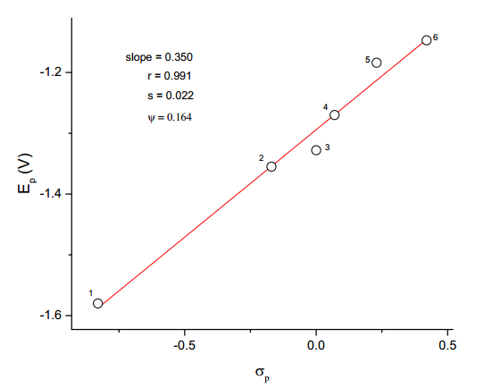

**Figure 5.13**. Hammett plot for the first peak potential (Ep) of the electrolytic reduction of

4′-substituted (E)-1-(furan-2-yl)-3-phenylprop-2-ene-1-ones.

Sweep rate = 40 mV/s.

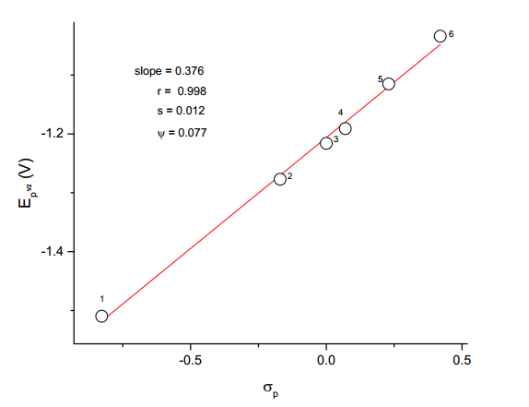

1. -NMe2
2. -Me
3. -H
4. -F
5. -Cl
6. -CHO

Slope = 0.376

r = 0.998

s = 0.012

ψ = 0.077

**Figure 5.14**. Hammett plot for the first half peak potential (Ep1/2) of the electrolytic reduction

of 4′-substituted (E)-1-(furan-2-yl)-3-phenylprop-2-ene-1-ones.

Sweep rate = 40 mV/s.

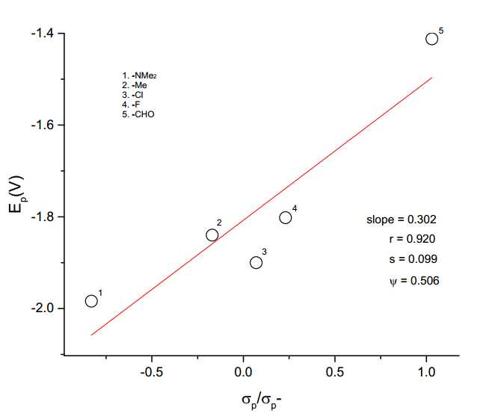

**Figure 5.15**. Hammett plot for the second peak potential (Ep) of the electrolytic

reduction of 4′-substituted (E)-1-(furan-2-yl)-3-phenylprop-2-ene-1-ones.

Sweep rate = 320 mV/s.

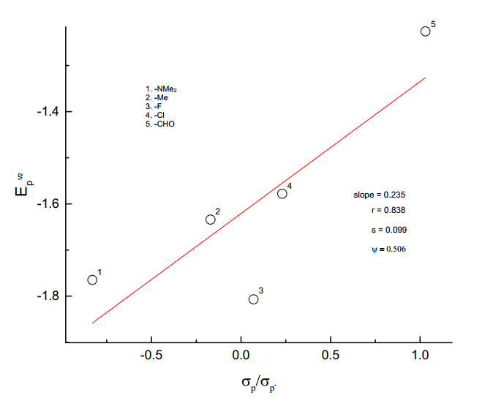

3

**Figure 5.16**. Hammett plot for the second peak half potential (Ep1/2) of the electrolytic

reduction of 4′-substituted (E)-1-(furan-2-yl)-3-phenylprop-2-ene-1-ones.

Sweep rate = 320 mV/s.

**5.4 Conclusion**

. Voltammetry reduction of 4′-substituted (E)-1-(furan-2-yl)-3-phenylprop-2-ene-1-ones in acetonitrile containing tetrabutylammonium tetrafluoroborate (TBATFB) as a supporting electrolyte has been carried out by employing glassy carbon electrode. Cyclic voltammetry reduction of (E)-1-(furan-2-yl)-3-phenylprop-2-ene-1-one gives two separate irreversible one-electron peaks. A mechanism involving two separate addition of single electron has been suggested. Correlations have been made with the Ep and Ep1/2of the first peak of 4′-substituted (E)-1-(furan-2-yl)-3-phenylprop-2-ene-1-ones with substituent constants separately. Better correlations are obtained with σp,σp/ σp+, σp+/ σp-, σp+/ σp/ σp- constants. A positive value of *ρ* is obtained showing that electron attracting substituents accelerate the electrochemical reduction and electron donating substituents retard it. The Hammett correlation for the second reduction peak of

4′-substituted (E)-1-(furan-2-yl)-3-phenylprop-2-ene-1-ones is poor.

**5.5 References**

1. P.T. Kissinger and W. R. Heineman*, J.Chem. Educ*., **60**, 702 (1983).

2. P.T. Kissinger and D.A. Roston*, J.Chem. Educ*., **60**, 772 (1983).

3. A.J. Bard and L. Faulkner, ‘*Electrochemical Methods-Fundamentals and Applications’*,

John Wiley and Sons, Inc., (1980).

4. J.M.A. Empis and B.J. Herold, *J.Chem.Soc., Perkin Trans. 2*, 425 (1986).

5. G.M. Proudfoot and I.M. Pitchie, *Aust. J.Chem*., **36**, 885 (1983).

6. T. Sato, K. Torizuka, R. Komaki and H. Atobe, *J.Chem. Soc., Perkin Trans, 2*, 561, (1980).

7. S. J. Reddy and V.R. Krishnan, *Indian J.Chem*., **22A**, 800 (1983).

8. M.M. Baizer, J.D. Anderson, J.H. Wagenknecht, M.R. Ort and J.P. Petrovich,

Electrochim.Acta., **12**, 1377 (1967).

9. M.M. Baizer and J.P. Petrovich, *J.Electrochem. Soc*., **114**, 1023, (1967).

10. J.P. Petrovich, M.M. Baizer and M.R. Ort, *J. Electrochem. Soc*., **116**, 743 (1969).

11. J.P. Petrovich, M.M. Baizer and M.R. Ort, *J. Electrochem. Soc*., **116**, 749 (1969).

12. M.M. Baizer, J.P. Petrovich, and D.A. Tyssee, *J. Electrochem. Soc*., **117**, 173, (1970).

13. J.P. Petrovich and M.M. Baizer J. *Electrochem. Soc*., **118**, 447, (1971).

14. M.M. Baizer and J.L. Chruma, *J.Electrochem. Soc*., **118**, 450 (1971).

15. M.Y. Duarte, C. Malagana, L. Nucci, M.L. Foresti and T. Guidelli*, J.Chem.Soc., Faraday*

*Trans 1*, 97 (1988).

16. M.Y. Durate, G.Pezzatini and R.Guidelli, *J.Chem.Soc., Faraday Trans 1*, 367 (1988).

17. P. Manisankar, R. Santhanam, T. Vasudevan and A. Baskar, *B. Electrochem*., **10**, 68,

(1994).

18. W.V. Childs, J.T. Maloy, C.P. Keszthelyi and A.J. Bard, *J.Electrochem.Soc*., **118**, 829

(1971).

19. V.J. Puglisi and A.J. Bard, *J.Electrochem*.Soc., **119**, 829 (1972).

20. N. Sulochana and P. Nagarajan, *B. Electrochem*., **8**, 597 (1992).

21. N. Sulochana and P. Nagarajan *J*. *Indian Chem.Soc*., **70**, 725 (1993).

22. L. Spritzer and P. Zuman, *J. Electroanal. Chem*., **126**, 21 (1981).

23. M.M. Srivastava, Mukhtar sinh and S.N. Srivastava, *Indian J. Chem*., **23A**, 591 (1984).

24. R.M. Bastida, E. Brillas and J.M. Costa, J*. Electroanal. Chem*., **227**, 55 (1987).

25. D.J. Arjona, M. Rhed and J.J. Rhiz, *J. Electroanal.Chem*., **239**, 239 (1988).

26. E. Lamy, L. Nedjo and N.K. Saveant, *J. Electroanal*. Chem., **42**, 189 (1973).

27. S. Wawzonek and A, Gunderson, *J.Electrochem.Soc*., **111**, 324 (1964).

28. S.C. Riffin and D.H. Evans, *J.Electrochem.Soc*., **121**, 769 (1974).

29. L.A. Avaca and J.H.P. Utley*, J.Chem.Soc*., Perkin II, 161 (1975).

30. ‘*Organic Electrochemistry’* ed. M.M. Baizer, Marcel Dekker, New York, 679 (1973).

31. L.H. Klemn, D.R. Olson and D.V. White*, J.Org.Chem*., **36**, 3740 (1971).

32. L.H. Klemn, and D.R. Olson*, J.Org.Chem*., **38**, 3390 (1973).

33. C.L. Ye, J.W. Liu, D.Z. Wei, Y.H. Lu and F. Qian, *Pharmacological Research*, **50(5**), 505

(2004).

34. Chetana and B. Patil, *J.Pharm.Sci. & Res*., **1**, 11 (2009).

35. B. Uslu and S.A. Ozkan, *Analytica Chemica Acta*, **462(1),** 49 (2002).

36. J.M. Kauffmann, M.P. Prete, J.C. Vire, G.J. Patriarche and Fresenius, *Journal of*

*Analytical Chemistry,* **321(2**), 172 (1985).

37. F. Belal, H. Abdinic and N. Zoman, *Journal of Pharmaceutical and Biomedical Analysis,*

**26(4),** 585 (2001).

38. P. Zuman, *Analytical Letters,* **33(2**), 163 (2000).

39. T.B. Demireigil, S.A. Ozkan, O. Coruh and S. Yilmaz, *Electroanalysis*, **14(2**), 122 (2002).

40. S. Yellappa and M. Mallappa, *European Journal of Research and medical Research*, **2(7),**

146 (2015).

41. K.M. Naik and S.T. Nandibewoor, *American Journal of Analytical Chemistry*, **3**, 656

(2012).

42. D.T. Sawyer and J.L. Robers, *Experimental Electrochemistry*, Wiley, New York, 1974.

43. L.A. Avaca and J.H.P. Utley, *J. Chem.Soc., Perkin* *I*, 971, (1975).

44. P. Zuman, The *Elucidation of Organic Electrode Process*, Academic Press, New York,

1969.

45. K. Alwair and J. Grimshaw, *J.Chem.Soc., Perkin II*, 1150, (1973).

46. J.E. Kudar, H.W. Gibson and D. Wychick, *J.Org.Chem*., **40**, 875, (1975).

47. S. Millefiori and A. Millefiori, *J.Chem.Soc., Faraday Trans II*, **77**, 245 (1981).

48. P.N. Gupta and S.A. Bhat, *J.Electrochem.Soc*., India, **30**, 209 (1981).

49. N. Patnaik, M. Mohanty and B.N. Pattanaik*, B.Electrochem*., **8**, 305, (1992).

50. D. Velayutham, T. Vijayabharathi, R. Kannakam Srinivasan and S. Chidambaram,

*B.Electrochem*., **5**, 742 (1989).

51. D.K. Gosser, “*Cyclic Voltammetry: Simulation and Analysis of Reaction Mechanisms”*

Vancoouver Coastal Health, New York, 1993.

52. A.J. Bard and L.R. Faulkner “*Electrochemical Methods Fundamentals and Applications*”

2nd Edition, Wiley, Hoboken, 2004.

53. K. Alwair, J.F. Archer and J. Grimshaw, *J.Chem.Soc., Perkin II*, 1663 (1972).

54. P. Venkata Ramana, D. Vasudevan and L.K. Ravindranath, *J. Indian Chem.Soc*., **71**, 123

(1994).

55. P.N. Gupta and S.A. Bhat, *J.Electrochem.Soc*., India, **30**, 209 (1981).